Sanilac Intermediate School District
Special Education Services

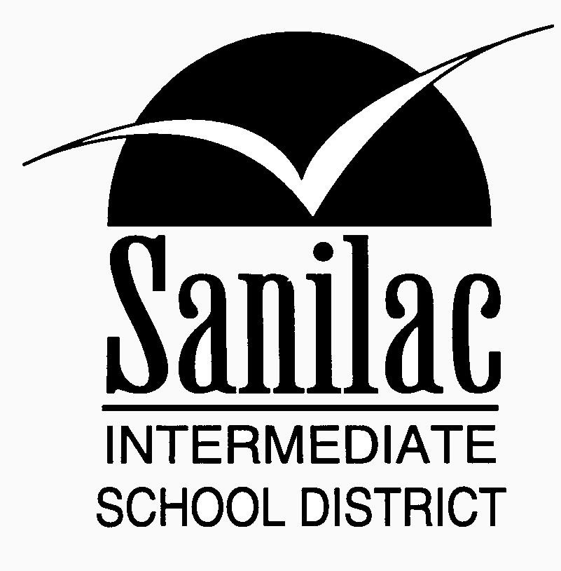

PARENT HANDBOOK

Sanilac Intermediate School District
in partnership with
the Parent Advisory Committee and
Brown City Community Schools
Carsonville-Port Sanilac Schools
Croswell-Lexington Community Schools
Deckerville Community Schools
Marlette Community Schools
Peck Community Schools
Sandusky Community Schools

